MECH 420 – Prelab 4

Kyle Ah Von #57862609

1. Plot the relationship for a displacement range and Icoil.

The spring constant for the stiffest spring: 1.4711 N/mm

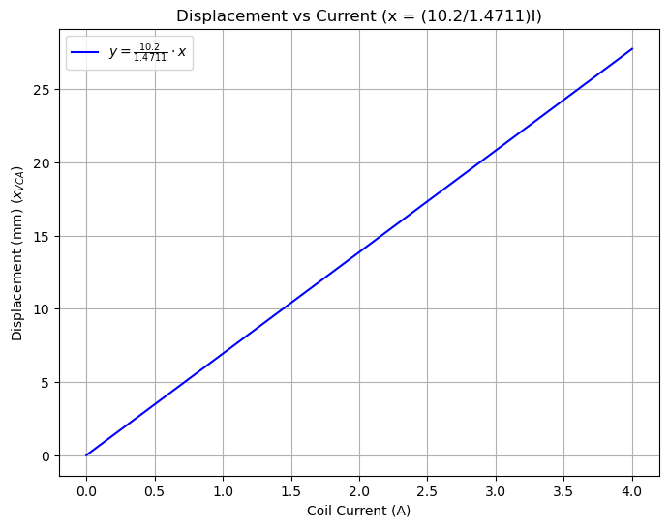

The equation is $X_{VCA}=\frac{Bl}{k}I$

1. For a moving mass m = 0.25 kg (neglecting friction) and for the same spring as in 1), determine the Input Impedance of the VCA coil as a function of f for 1 Hz < f < 1kHz and plot its magnitude as a function of frequency.

We can see that there is a resonant frequency at 76.7 Hz given by $\frac{1}{2π}\sqrt{\frac{k}{m}}$, which can be seen by the peak in magnitude at that frequency.

1. How will the resonant frequency change if mass m1 = 0.25 kg is added?

As total mass increases to 0.5 kg, the resonant frequency is given by $\frac{1}{2π}\sqrt{\frac{k}{m}}$ which then leads to a new frequency of 54.2 Hz as the mass is doubled, which can be seen by the left shift in the peak. The magnitude of the peak is also smaller than the peak with a lower mass.

1. The system (without added mass) should be excited by a square wave signal with 50% duty cycle. Choose a cycle time for this signal such that only the fundamental frequency and the first upper harmonic are both below the resonant frequency.

